Nail Care and Ingrown Nails
Nails are an important part of your body to keep healthy. Nails start growing from underneath the skin, where the U-shaped edge of the nail touches the skin. If you look closely, you can see an almost clear, thin sliver of skin at this U-shaped edge called the cuticle. The cuticle protects the nail from infection.
Nails grow very slowly with new nail cells pushing out older ones. The old nail cells that make up the hard part of our nails are dead cells, which is why it does not hurt when we cut our nails. It can take 3-6 months to completely replace an entire fingernail. Toenails grow even slower, and can take up to 18 months for an entire toenail to be replaced.
Healthy nails are typically pink in color, with a smooth surface, and should not be painful. If your nails are discolored, have an rough surface, or are causing you pain, this may be a sign that your nails are not healthy.
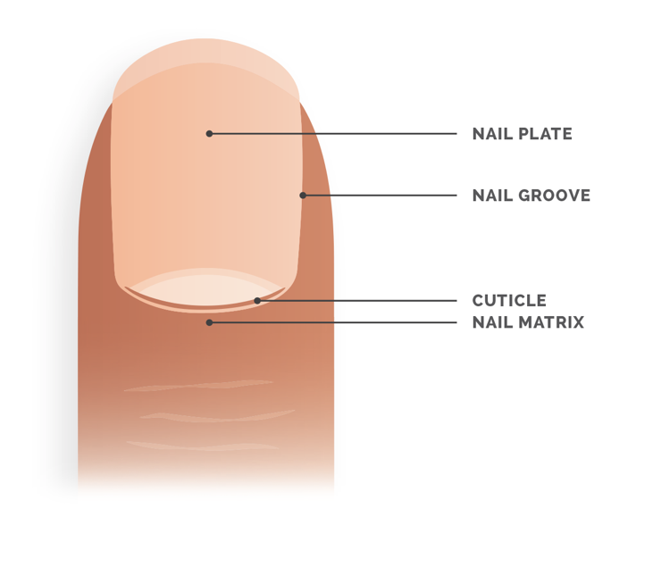
Parts of the Nail:
- Nail plate: This is the hard part of the nail
- Nail groove: The groove along the sides of the nail, between the nail and the skin
- Cuticle: The thin sliver of skin at the edge of the nail
- Nail matrix: The area under the cuticle where new nail is formed

Nail Care
- Regularly trim your fingernails and toenails with a nail clipper or nail scissors.
- Keep nails trimmed straight across the top with a slight curve at the tip. Avoid cutting the corners of the nail too close to the skin. The sharp edge can dig in and cause pain or infection.
- If the nail edges are rough after trimming, you can use a nail file or emery board to smooth out the nail edge.
- If your nails are hard and difficult to trim, try soaking or bathing first. This softens the nails and makes them easier to cut.
- Keep nails dry and avoid contact with water for long periods of time.
- Do not pick at, push back, or trim the cuticle. This can harm the protective layer of our nails.
- Avoid picking or biting nails.
- Apply hand lotion regularly on your hands and cuticles to keep them moisturized.
- Before applying darkly-colored nail polish, apply a nail polish base coat to prevent staining.
- Eat a healthy, balanced diet to keep nails smooth and strong.
Ingrown Nails
- Ingrown nails can cause pain, swelling, and sometimes an infection. This is caused by the nail curving down and digging into your nearby skin. It mostly occurs on the great toe.
- An ingrown nail may start with redness, pain, and swelling where the toenail is digging into the skin. This can lead to an infection with yellow drainage called pus. Sometimes the pain can make it uncomfortable to walk.
- If the ingrown nail is left untreated, the sharp nail corner can become buried inside the swollen skin, causing even more pain.
- Ingrown nails can worsen when you try to trim the corner that is causing pain. This is because the freshly trimmed hard nail can act like a sharp knife and cause more trauma to the skin. This makes the pain and swelling worse.
How to Prevent Ingrown Nails
- Regular nail care and trimming can help prevent ingrown nails.
- Wear shoes with a proper fit. Avoid shoes that are tight, especially at the toes.
- Avoid trimming the corner of the toenails too short.
- Prevent repeated trauma to the toe. This is especially important when playing sports that involve running and kicking.
How to Treat Ingrown Nails
- An ingrown nail needs to be assessed and treated by your medical provider.
- If the ingrown nail is mild, treatment can include switching to more comfortable footwear, soaking the toe in warm soapy water, applying topical medications, or placing cotton wisps under the corner nail edge.
- If the ingrown nail is more severe or infected, oral treatment with antibiotics may be needed.
- For patients with recurrent ingrown nails, surgery may be needed to remove part of the nail that is causing pain.

